**Experiment No. 4**

|  |  |  |  |
| --- | --- | --- | --- |
| **Student Name:** | Harshit | **UID:** | 21BNM2066 |
| **Branch:** | BSC CSM | **Section/Group:** | A |
| **Semester:** | 5 | **Date of Performance:** | 11-9-23 |
| **Subject Name:** | Web Design Lab | **Subject Code:** | 21SCP-322 |

|  |  |
| --- | --- |
| **Statement** | Design a web page of your home town with an attractive background color, text color, an Image, font etc. |
| **Aim** | Use internal CSS |
| **Objectives** | 1. Using CSS. 2. Attractive background color, text color, an Image, font etc. |
| **Language** | HTML, CSS |

**Code:**

<!DOCTYPE html>

<html lang="en">

<head>

<meta charset="UTF-8">

<meta name="viewport" content="width=device-width, initial-scale=1.0">

<title>Chandigarh</title>

<style> body, h1, h2, h3, p { margin: 0; padding: 0;

} body {

background-color: #b0c4de; color: #003153;

font-family: Arial, sans-serif;

} header {

background-color: #333; text-align: center;

padding: 20px 0;

} header h1 { font-size: 36px; color: #fff;

} nav { text-align: center;

background-color: #444;

} nav ul { list-style-type: none; padding: 0;

} nav ul li { display: inline; margin-right: 20px;

} nav ul li a { text-decoration: none; color: #fff;

} nav ul li a:hover { text-decoration: underline;

}

.hero {

background-image: url('https://static.toiimg.com/photo/24700302/.jpg'); background-size: cover; background-position: center;

height: 400px; text-align: center; color: #f2f3f4;

padding-top: 100px;

}

.hero p{ margin: 20px;

}

.hero h2 { font-size: 48px;

margin-bottom: 20px;

}

.welcome { text-align: center; color: #1c2841;

padding: 20px;

}

.attractions { padding: 40px; color: #1c2841; text-align: center;

}

.attraction { margin-bottom: 20px; color: #1c2841; margin-left: 10vw;

margin-right: 10vw;

}

.attraction img { max-width: 100%; height: auto;

} footer {

background-color: #333;

color: #fff; text-align: center;

padding: 10px 0;

}

</style>

</head>

<body>

<header>

<h1>CHANDIGARH</h1>

</header>

<nav>

<ul>

<li><a href="#attractions">Key Attractions</a></li>

<li><a href="#events">Local Events</a></li>

<!-- Add more navigation links as needed -->

</ul>

</nav>

<div class="hero">

<h2>Welcome to Chandigarh</h2>

<p>Discover the beauty and culture of the City Beautiful.</p>

<br>

<p>Chandigarh is a union territory and planned city in northern India, serving as the shared capital of the surrounding states, namely Punjab to the north, west and the south, and Haryana to the east.</p>

<p>Chandigarh is one of the earliest planned cities in post independence India and is internationally known for its architecture and urban design. The master plan of the city was prepared by Swiss-French architect Le Corbusier.

Chandigarh has grown greatly since its initial construction, and has also driven the development of Mohali and Panchkula; the "tri-city" metropolitan area has a combined population of over 1,611,770.

The name Chandigarh is a compound of Chandi and Garh. Chandi refers to the Hindu goddess Chandi and Garh means fortress. The name is derived from Chandi Mandir, an ancient temple devoted to the Hindu Goddess Chandi near the city in Panchkula District.

Chandigarh is located by the foothills of the Shivalik Range of the Himalayas in northwest India. It covers an area of approximately 114 km2. It borders the states of Punjab and Haryana.

Many trees in Chandigarh are given the status of the natural heritage of the city. The Chandigarh government has identified a list of 31 trees as Heritage Trees.

The government is a major employer in Chandigarh, with three governments having their base here, those being the Chandigarh Administration, the Punjab government and the Haryana government.

A significant percentage of Chandigarh's population, therefore, consists of people who are either working for one of these governments or have retired from government service, mainly armed forces.</p> </div>

<div class="welcome">

<p>Explore the charm and history of Chandigarh through our website. We invite you to discover our key attractions and exciting local events.</p>

</div>

<div class="attractions" id="attractions">

<h2>Key Attractions</h2>

<div class="attraction">

<img

src="https://upload.wikimedia.org/wikipedia/commons/thumb/2/25/Waterfall_at_Rock_Garden%2C_Chandigarh. jpg/1024px-Waterfall_at_Rock_Garden%2C_Chandigarh.jpg" alt="The Rock Garden">

<p><b>The Rock Garden</b> of Chandigarh is a sculpture garden for rock enthusiasts in Chandigarh, India. It is also known as Nek Chand Saini's Rock Garden of Nathupur after its founder Nek Chand Saini, a government official who started building the garden secretly in his spare time in 1957. It has spread over an area of 40 acres (16 ha), and is completely built from industrial, home waste, and discarded items.</p>

</div>

<div class="attraction">

<img src="https://upload.wikimedia.org/wikipedia/commons/7/7c/Chandigarh_Lake.jpg" alt="Sukhna Lake">

<p><b>Sukhna Lake</b> in Chandigarh, India, is a reservoir at the foothills (Shivalik hills) of the Himalayas. This 3 km² rain fed lake was created in 1958 by damming the Sukhna Choe, a seasonal stream coming down from the Shivalik Hills.

</p>

</div>

<div class="attraction">

<img

src="https://upload.wikimedia.org/wikipedia/commons/thumb/d/dc/Rose_Garden_%2CChandigarh_UT.jpg/1280p x-Rose_Garden_%2CChandigarh_UT.jpg" alt="Zakir Hussain Rose Garden">

<p><b>Zakir Hussain Rose Garden</b>, is a botanical garden in Chandigarh, India and spread over 30 acres of land, with 50,000 rose-bushes of 1600 different species.

Named after India's former president, Zakir Husain and created in 1967 under the guidance of Mohinder Singh Randhawa, Chandigarh's first chief commissioner,

the garden has the distinction of being Asia's largest. The garden has not only roses, but also trees of medicinal value. Some of the medicinal plants that can be spotted here are bel, bahera, harar, camphor and yellow gulmohar.</p>

</div>

<div class="attraction">

<img

src="https://upload.wikimedia.org/wikipedia/commons/thumb/1/1a/Palace_of_Assembly_Chandigarh_2006.jpg/1

920px-Palace_of_Assembly_Chandigarh_2006.jpg" alt="The Palace of Assembly">

<p><b>The Palace of Assembly</b> is a building in Chandigarh, India which houses the Punjab Legislative Assembly and the Haryana Legislative Assembly.

It was designed by modernist architect Le Corbusier. It is part of the Capitol Complex, which includes the Legislative Assembly, Secretariat and High Court.

The Palace of Assembly features a circular assembly chamber, a forum for conversation and transactions, and stair-free circulation.</p>

</div>

<div class="attraction">

<img

src="https://upload.wikimedia.org/wikipedia/commons/2/22/Government_Museum_and_Art_Gallery%2C_Chand igarh..jpg" alt="Government Museum and Art Gallery">

<p><b>Government Museum and Art Gallery</b>, Chandigarh, is a premier museum of North India having collections of Gandharan sculptures, sculptures from ancient and medieval India,

Pahari and Rajasthani miniature paintings. It owes its existence to the partition of India in August, 1947. The museum has one of the largest collection of Gandharan artefacts in the world.</p> </div>

<a href="https://en.wikipedia.org/wiki/Chandigarh#Tourist_attractions">More Attractions</a> </div>

<footer>

<p>Contact us at @email.com | Follow us on <a href="#">Facebook</a> and <a href="#">Twitter</a></p>

<p>&copy; 2023 Chandigarh. All rights reserved.</p>

</footer>

</body>

</html>

**Observations/Outcomes:**

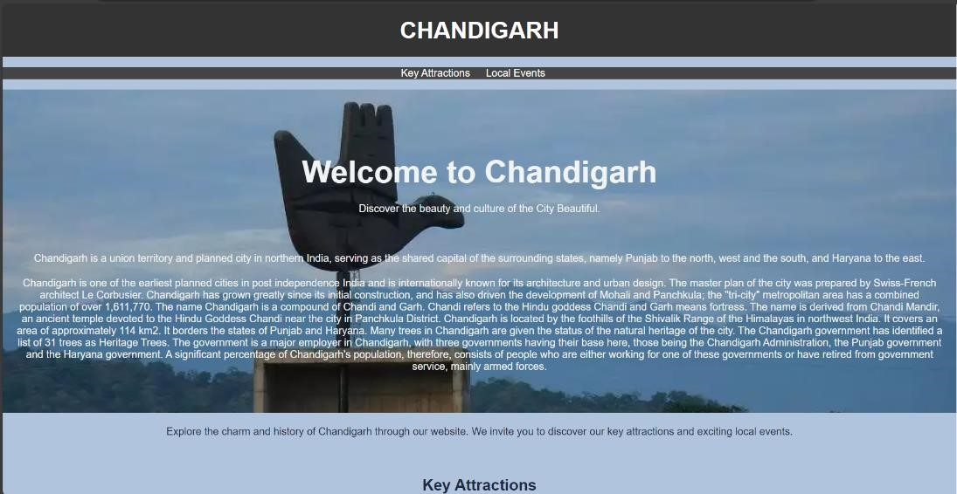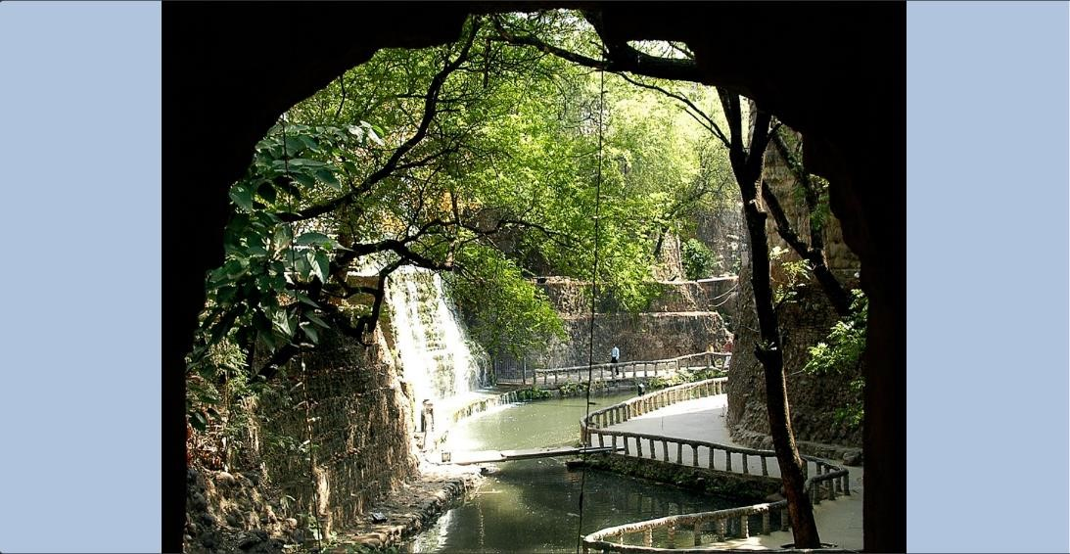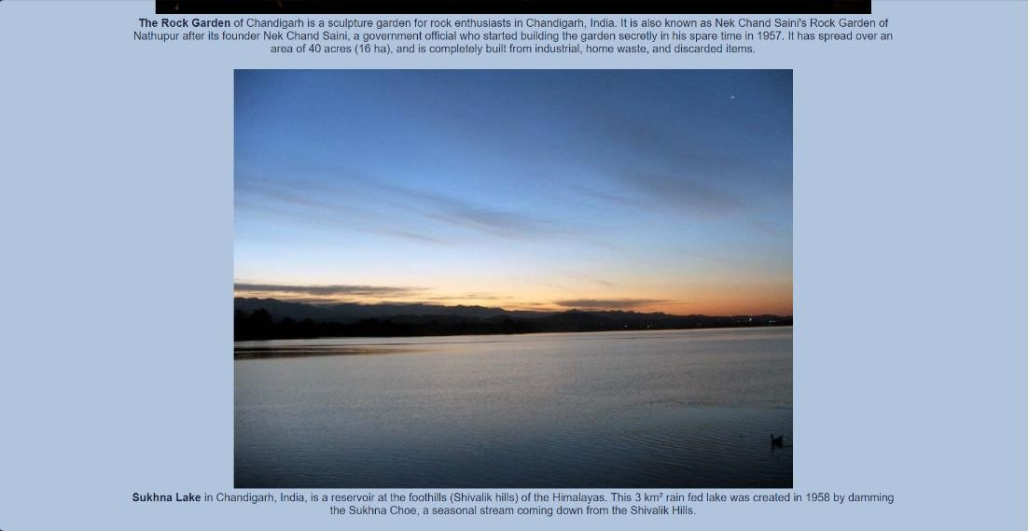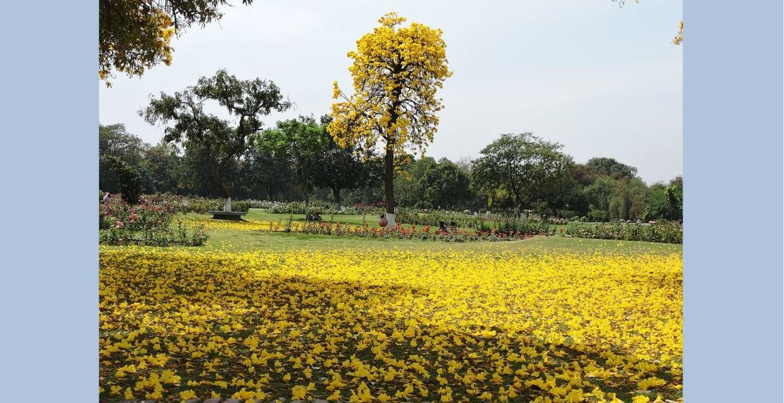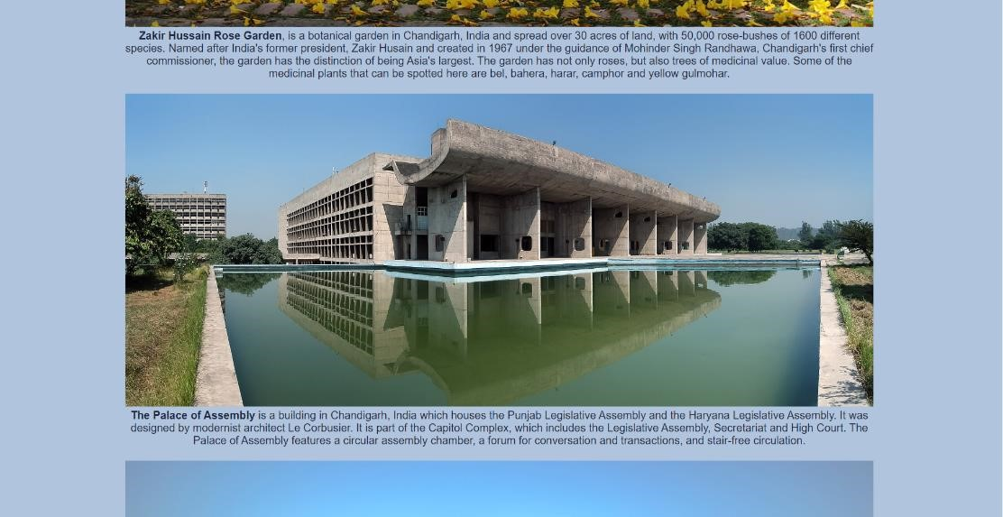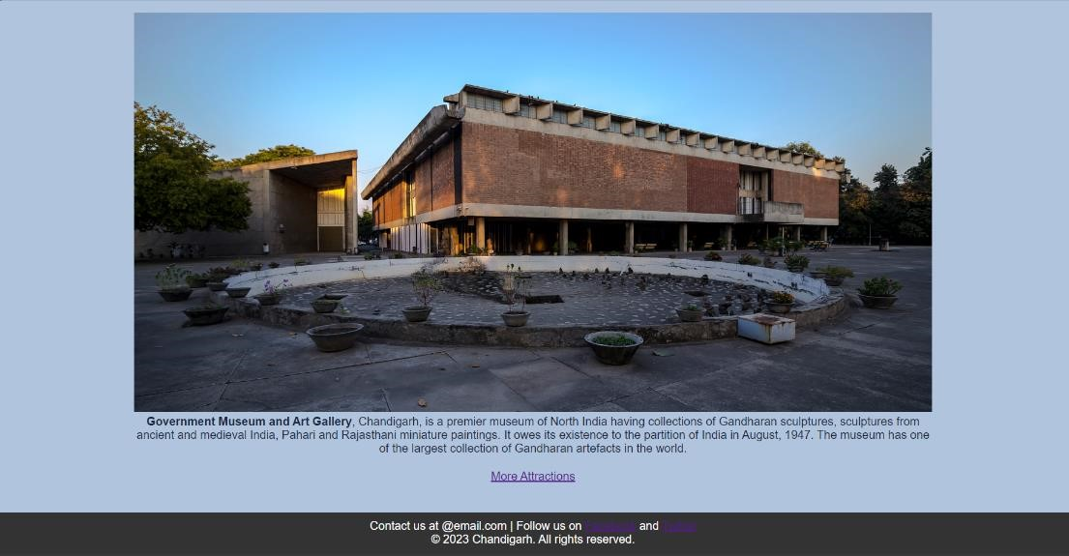

**Evaluation Grid (To be created as per the SOP and Assessment guidelines by the faculty):**

|  |  |  |  |
| --- | --- | --- | --- |
| **S.N.** | **Parameters** | **Marks Obtained** | **Maximum Marks** |
| **1.** | Conduct of Experiment |  | 12 |
| **2.** | Viva-voce |  | 10 |
| **3.** | Submission of Work Sheet |  | 08 |